Aaron Jencks
2/8/2017
Communication systems

RFID, an In-Depth overview

RFID stands for Radio-frequency identification, it is used to identify objects via a wireless transponder and reader. There are two types of transponders, passive, and active; passive transponders can be as simple as just an antenna which resonates and reflects energy received by the reader back to the reader, which interprets that signal to identify the object, while active transponders, use a local power source to transmit a week RF signal that can be read by the reader to interpret what the object is. An advantage to using passive transponders is that they can be very small, but, they require almost a thousand times more power to be read, than an active transponder. An active transponder is similar to a passive transponder, but it periodically transmits its id every so often, or when a reader is present. These transponders have many applications in retail, and the automotive industry, as well as several other places.
The RFID gets its start officially in 1973, but there are signs of similar systems being used as far back as 1945. In 1945, Leon Theremin created an espionage tool for the Russians that is officially known as the predecessor to the RFID, it was a simple passive device that collected audio information and modulated a waveform received by the reader with the information (See Illustration 1). In WWII, a process similar to RFID was used to determine if aircraft was friend or foe, this was the IFF Transponder, and is still used by most powered aircraft to this day.
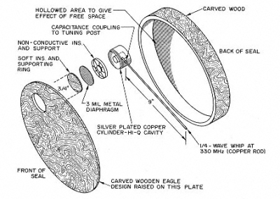Illustration 1: Theremin's listening device
In 1971 the first official RFID system was demonstrated to the New York Port Authority, this was what would evolve into the FasTrack system that we use on tollways today. In 1973, Los Alamos Labs developed the true system for UHFID that is currently adopted, it operates at 915 MHz and uses 12-bit tags. The first patent was filed on 1983.
When it comes to operation, RFID systems operate in several modes: Passive Reader Active Tag (PRAT), Active Reader Passive Tag (ARPT), and Active Reader Active Tag (ARAT). The frequency that the system operates at is defined by ISO/IEC 18000. With PRAT, a passive reader is activated when an active tag sends information to it, which has a large operating range. ARPT involves an active reader/interrogator sending a signal to a passive tag, which responds with information. ARAT involves an active tag that lays dormant until a reader sends it an RF signal which causes it to awaken and respond with its own information, this is useful in stores because it allows for close tag activation range and specified reading areas, like the front doors of the store.
Tag types are similar to the different types of ROM in computers; some are read-only, some are read/write, some are write once read many (like CDs). Most tags consist of 3 parts: An integrated circuit for storing and processing data to be modulated or de-modulated, a means of getting a DC power, and an antenna for transmission/reception (See illustration 2 on the next page).
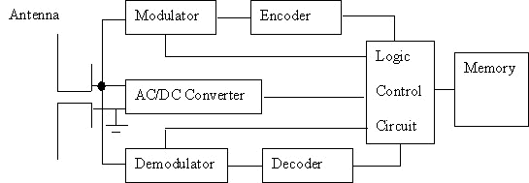Illustration 2: Typical Passive Tag Schematic
RFID has many uses in today's society, ranging from automotive tracking and tolls, to credit cards, and animal tracking. RFID is widely used today because of its small size and large number of applications. In automotive, RFID is used to track serial/vin numbers on cars, to track pieces along assembly lines, and to manage tolls automatically via FasTrack. Credit Cards use RFID because of the small size, can you imagine carrying around a full radio transmitter in your pocket instead of a card? But that's not where they stop, ATMs also use RFID to track money amounts and locations, and maintenance. RFID is also used in retail for not only stock management, but also for theft protection, those clippy things they have on clothes and the cases they have to take off of expensive items are RFID tags that are synced to the readers/interrogators at the entrances to the store (the security bars) which is an example of an ARAT system. Finally, RFID is also used in animal tracking because of its small size and ability to be embedded within the animal, which also acts as a form of theft prevention, since they can't just tear the tag/collar off of the animal anymore to claim it as their own, it also helps for locating lost animals via gps, and last but not least, it also provides the same services as retail for stock management and inventory automation.

